Transportation Service System for Grocery Kart using Genetic Algorithm
Deepank Kartikey, Vanmathi C.
School of Information Technology and Engineering, VIT University,
Vellore, India
deepankkartikey@gmail.com, vaanmathiengr@gmail.com

Abstract
Transportation is a major problem domain in logistics, and so it represents a substantial task in the activities of many companies. In some market sectors, transportation means a high percentage of value added to goods. As per this day there is no deterministic approach invented which will give the best result and solves the problem of Vehicle routing with time windows. In Vehicle Routing Problem (VRP), the aim is to find a set of m minimum cost vehicle routes through n customer locations, such that each route starts and ends at a common location and some side constraints are satisfied. Many heuristic approaches have been invented to approximate the solution and improve the solution previously achieved by different researchers. I have accepted this challenge which tends to address the delivery of grocery to various stores from warehouses and determine the best paths based on route evaluation, best available routes, determine an optimum number of trucks required, profit, cost and efficiency analysis. Various comparative reports will be generated for various user and city data. More specifically, we consider the distance, fixed cost, time, together with risk simultaneously. To get a quicker and more accurate solution, several improvements are proposed in applying GA for optimization search. I am using multi- objective genetic algorithm (GA) to address the problem to obtain optimum solutions.

Keywords: Transportation, Genetic Algorithm, Vehicle Routing, Crossover, Optimization, Minimum Cost

- INTRODUCTION
GroceryKart.com is responsible for supplying fresh vegetables and produce to all retail stores in a state. There are about 600 stores in their network. They have a fleet of old Matador vans that are being used to haul the goods from their central warehouse in Andheri. The goods are perishable by nature; hence all vans leave at 5:00 AM and all deliveries must happen before 8:00 AM. Each van can make multiple stops (s) but the union contract prevents any truck from making more than 20 stops or travelling more than 65 KM in any trip.
To reduce costs and minimize greenhouse emissions, GroceryKart.com is planning to retire all the old Matador vans and purchase a new fleet of Mahindra vans. They believe the cost of purchasing the Mahindra vans will more/less be covered by the sale of Matador vans and the rest of the money will come from the existing savings fund. However, maintaining each truck costs Rs. 20,000 a month (including the driver, etc.). Also, the variable cost/km of travel is around Rs. 30 for the first three years of the truck usage. Each Mahindra truck can carry up to 1000 kg at full capacity and at the end of the trip, all trucks return to the warehouse. Each stop at the store takes 5 minutes to download (irrespective of the weight) and every KM travelled takes 90 seconds on an average.
The aim is to determine the number of Mahindra vans required to be purchased and the total KM that will be travelled to service the daily demand of all the stores to minimize the total cost over the first three years?
Also, determine
- The number of trucks needed
- Routing for each truck and
- The total miles travelled each day

Transportation Service System for Grocery kart is a multi-objective optimization problem, which needs a suitable approach to obtain a global optimum solution. So, for this high complexity problem without any known sophisticated solution technique, a genetic approach is well suited. In the optimization process, due to the problem specific encoding, the genetic algorithm enables me to compute and optimize the routing quiet easily as compared to the other deterministic approaches. A Genetic algorithm is a search heuristic which mimics the process of natural evolution. Genetic algorithms use techniques like selection, crossover and mutation which are inspired by natural evolution to generate solutions for specified problems.
- RELATED WORK
A genetic algorithm is based on a natural selection process that mimics biological evolution used as a method for solving both unconstrained and constrained optimization problems. The population of individual solutions is repeatedly modified with span of time. At every step, individuals are selected randomly from the current population and used as parents to produce the children for the future generation. Over successive generations, the population "evolves" toward an optimal solution.
Some basic terms related to Genetic algorithms:
- Population is the subset of all the possible (encoded) solutions to the given problem.
- Chromosome refers to a candidate solution to the given problem.
- Gene refers to one element position of a chromosome.
- Allele refers to the value a gene takes for a chromosome.
- Genotype refers to the population in the computation space. The solutions are represented in a easily understandable way and can be easily manipulated using a computing system.
- Phenotype refers to the population in the actual real-world solution space where solutions are represented just like in real world situations.
- Decoding and Encoding
The decoding means the process of transforming a solution from the genotype to the phenotype space, while encoding means the process of transforming from the phenotype to genotype space. Decoding should always be fast as it is carried out repeatedly in a GA during the calculation of fitness value.
- Fitness Function simply is a function which takes the solution as input and calculates the suitability of the solution as the output.
- Genetic Operators alter the genetic composition of the offspring. Some of the genetic operators are a crossover, mutation, selection, etc.
The problems related to transportation of goods, commodities and people have been relevant since 1959. The article in which the phrase “Vehicle routing” appeared for the first time is attributed to Golden [1]. Other versions of Vehicle Routing Problem (VRP) appeared in the early 70s. Some mathematical models which represent routing problem related to the collection of wastes have been highlighted by Liebman and Marks [3]; Levin [4] posed the problem of fleet vehicles; Later the problem of persons with disabilities for telephone request of transportation service was presented by Wilson [2] and Marks and Stricker presented a model for routing public service vehicles. Golden and Stewart tried associating some probabilistic concepts with the problem.

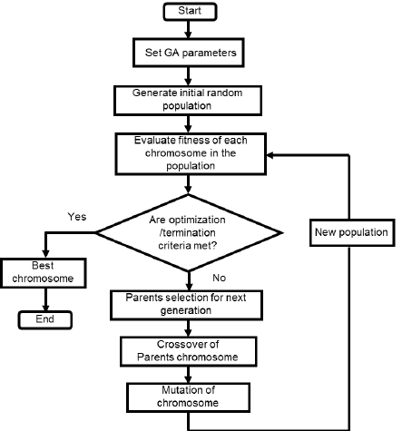Fig. 1. Working of Genetic Algorithm

The concept of constraints of time windows was included by Solomon [5]; Sariklis and Powell [6] proposed a problem where the vehicle does not return to the starting point of the journey. In recent time, some clearly defined conditions were added to approach any VRP in real-life problems, resulting in several variants which modify either constraints or objective function of the basic VRP optimization model.

In general, the objective of the VRP (Vehicle Routing Problem) is to design a set of minimum cost routes that servers to many places, geographically dispersed, and fulfilling specific constraints of the problem. In the past decade, there have been significant advancements in terms of the technical solutions to resolve large instances of VRP. The inclusion of technological innovations in the VRPs has gained interest. They include global positioning systems, radio frequency identification and usage of high-capacity computer information processing.
The Vehicle routing problem can be represented as follows: given a fleet of vehicles with uniform capacity, a standard depot, and a few customers demands, find the set of routes with overall minimum route cost which can service all the demands [7]. All the itineraries begin and end at the depot and they must be designed in such a way that every customer is served only by one vehicle and just once.
Genetic algorithms are inspired by the natural selection mechanism introduced by Darwin [8] which tells that fittest will survive. They apply certain operators to a population or solutions of the problem, in such a way that the new population is improved and is fitter when compared with the previous one according to a pre-specified criterion function. The procedure is performed for a pre-determined number of iterations and the output of the algorithm is the best solution found in the last population or, in some cases, during the evolution of the algorithm. Generally, the solutions of the problem are coded at hand and the operators are applied to the coded versions of the solutions. The way of coding of solutions lays an important role in the performance of a genetic algorithm. Inappropriate coding may lead to poor performance.
The operators being used by genetic algorithms mimic the process of natural selection. The well-known and widely used genetic operators are reproduction, crossover, and mutation operators applied in that order to the current population. In reproduction operator the solution which is fitter in current population will replicate more in the next population. The crossover operator selects pairs of solutions at random, splits them at a random position, and exchanges their second components; it is applied after reproduction operator. In mutation operator, an element of a solution randomly selected and alters it with some probability; it is applied to reproduction and crossover operators. Thus, GA serves as a searching technique used in computing true or approximate solutions to optimization and search related problems.
- PROPOSED WORK
The Genetic Algorithms are implemented using JAVA. A genetic algorithm has the following five steps.

3.1 Population initialization, two methods are being used:
generatePopuation(): it generates a diverse population
greedyGeneratePopulation(): it generates optimum solutions
3.2 Selection is being performed by using Tournament Selection concept. Tournament Selection consists of running several "tournaments" among a few individuals (or chromosomes) chosen at random from the population. The winner of each tournament (the one with the best fitness) is selected for crossover.
3.3 Fitness Evaluation is done by using following two methods:
Weighted Sum approach
Pareto Ranking: It is a state of allocation of resources where two individuals is dependent on each other such that if one individual tries to become more fit other individual’s fitness value goes down.

For Crossover, the user will be given two choices:

BCRC: Best Cost Route Crossover
BCRC not only maintains the candidates’ good nature but improves it too, to drive the force of obtaining better solutions by manipulating existing good candidates.

Algorithm:

- Mating pool of candidates/Population
- Each candidate has own routing scheme
- Random candidate selected (say c1)
- According to constraints, select another candidates (say c2i; i=1,2,3,4…)
- Mate c1, c2i
- Calculate fitness value
- i^{th} candidate with best fitness value selected
- Add selected candidate to new population

PMX: Partially Mapped Crossover
PMX aims at keeping as many positions from the parents. To get this, a sub-string is swapped like in two-point crossover and the values are kept in all other non-conflicting positions.
Then conflicting positions are replaced by values which were swapped to other
offspring.

Example:

p1= (1 2 3 4 5 6 7 8 9)
p2= (4 5 2 1 8 7 6 9 3)

Assume the position 4-7 are selected for swapping. Then the two offspring are given as follows if we omit the conflicting positions.
o1= (* 2 3|1 8 7 6|* 9)
o2= (* * 2|4 5 6 7|9 3)
Now take the conflicting positions & in what was swapped to the other offspring.
For eg 1 and 4 were swapped. Therefore we have to replace the 1 in the first position o1
by 4 & so on.

o1= (4 2 3 1 8 7 6 5 9)
o2= (1 8 2 4 5 6 7 9 3)

Mutation will be done by using Inversion Operator. The length of inversion will be
fixed to 2 or 3 which gets selected randomly and assigned to get flipped.

- Results
The required results for the user were obtained by giving the required inputs.

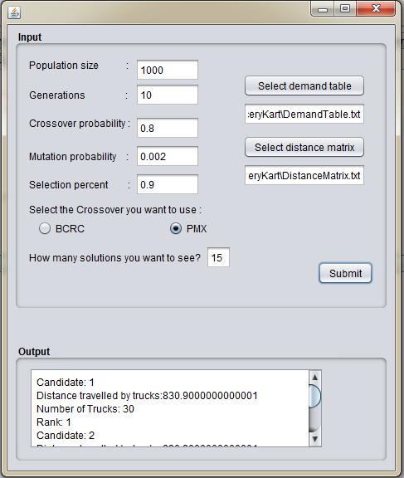

Fig 2: window providing various candidate generation with the total distance travelled and maximum number of trucks required the sorts the result according to the ranks.

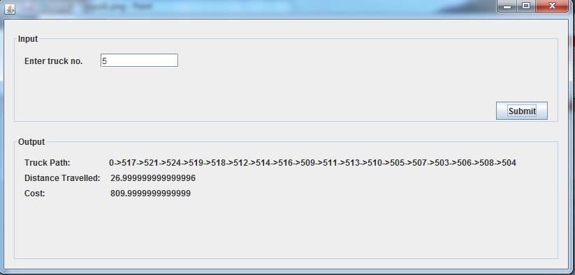

Fig 3: window shows the result for the truck number specified by the user. It provides the path of that truck (i.e. which all stores it visits) and the distance travelled by that truck and the cost incurred.

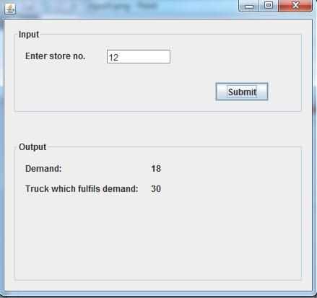

Fig 4: window shows the result for the store number specified by the user. It provides the demand of that store and which truck fulfils it

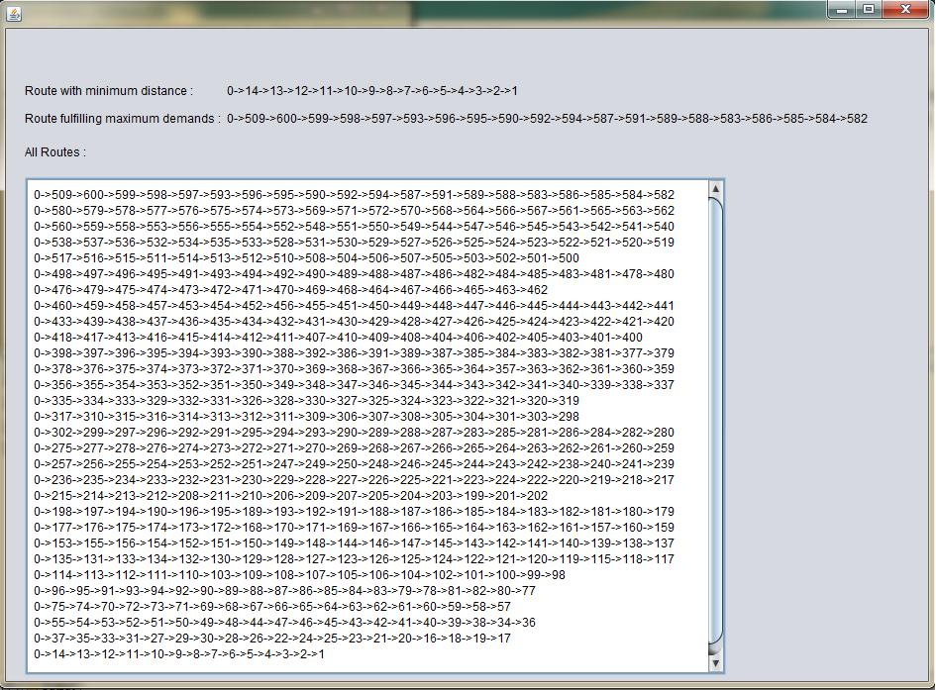

Fig 5: route evaluation window. The user inputs the various fields to calculate the various optimum results produced providing the trucks required and the routes and distance travelled by these trucks

- CONCLUSION
Transportation Service System for Grocery kart is a multi-objective optimization problem, which needed a suitable approach to obtain a global optimum solution. So, for this high complexity problem without any known sophisticated solution technique, a genetic approach was well suited. In the optimization process, due to the problem specific encoding, the genetic algorithm can compute and optimize the routing quiet easily as compared to the other deterministic approaches. Genetic algorithm is a search heuristic that mimics the process of natural evolution. They generate solutions to optimization and searching problems using techniques inspired by natural evolution, such as selection, crossover and mutation.

The basic problem which was solved here consisted of delivering goods from a depot to the stores. It consisted of a set of stores with known demands which had to be fulfilled through minimum-cost vehicle routes keeping the depot as the starting as well as terminating point. There were certain criteria that had to be taken care of, they were:

- All the deliveries are to be made between 5AM to 8AM.
- Maximum number of stops are 20.
- Travelling distance not more than 65 km.
- Maximum load capacity is 1000 kg.
- At the end of the trip, each truck returns to the central warehouse.
- Each stop at the store takes 5 min to download.
- Every km travelled takes 90 secs on an average

For this problem, initially generated a Random Population to maintain diversity and a Greedy Population to get optimal solutions. Then for the Selection used Tournament Rank selection which further optimised our dataset. Weighted Sum approach and Pareto Ranking (to get the alternative solutions of same nature) are the Fitness Evaluation procedure used.

Two types of Crossover were used here: -

The BCRC (Best Cost Route Crossover), maintains and improves the candidates’ good nature to drive the force of obtaining a better solution by manipulating existing good candidates

Partially mapped crossover (PMX) aims at keeping the most number of possible positions from the parents. To achieve this goal, a sub string is swapped like in two-point crossover & the values are kept in all other non-conflicting positions. The conflicting positions are replaced by the values which were swapped to the other offspring.

These two types of crossover were the basis of analysis and for the comparison of the results

Result Analysis

BCRC
Distance | Time Taken
799.88 | 20 min
807.8 | 12 min
812.1 | 2 min
Table 1. BCRC distance versus time taken

PMX |  | BCRC
Distance | Time Taken | Distance | Time Taken
818.1 | 1 min | 799.8 | 20 min
819.4 | 40 Sec | 807.8 | 12 min
821.5 | 30 Sec | 812.1 | 2 min
Table 2. PMX versus BCRC

From the results shown above which were compiled after the execution of the program we concluded that BCRC gives more optimum distance and takes more time for the execution and the population taken is less. Whereas for PMX gives less optimum distance and takes less time for the execution and the population taken is more.

From these conclusions we cannot judge the best out of the two but can be done in a aspect.

- BCRC is better than PMX in providing more optimum solution.

- PMX is better than BCRC as the execution time is less.

- FUTURE SCOPE
Genetic Algorithms are of major significance to the development of solutions to multi-objective and high complexity problems. The potential which they offer over existing techniques is enormous. They find application in biogenetics, computer science, engineering, economics, chemistry, manufacturing, mathematics, physics and other fields. And the list will continue to grow especially if Genetic Algorithms are combined with other optimization methods.
There is a great scope:
- For finding new crossover methods for more convergent steps.

- For finding new mutation methods for reducing divergence due to excess mutation.

- For finding a function which will decide a suitable number of initial populations.

The method used to solve this Transportation Service System for Grocery Kart problem can be referred to solve:
- Location Allocation Problems
- Real Coded Genetic Algorithm (RCGA) for Integer Linear Programming in Production Transportation problems.
- Network Designing and routing problems.
- Planning of Packet Switched networks.

The further working on optimization can be obtained by:
- We can use roulette wheel selection and rank selection also as mentioned in (Ombuki et.al 2006) in references. The paper described that as compared to tournament selection this selection method was slow and gives a nearly same answer.
- There are various other heuristic approaches mentioned in (Tan et.al 2000) LSD, Tabu search, Simulated Annealing and NSGA-II.

We can also us PFIH approach for generating a seed for population generation (Tan et.al 2000).
- Insertion mutation is another mutation approach which gives the same result as inversion.
- The best population can be passed as seeds and can improve the running time of Best Cost Route Crossover.
- The best till date solutions can be saved and pass them as initiators to BCRC Crossover and it will futher improve the result tremendously.
- There can be a new algorithm which can be invented and will run on updating the solutions only if any minimal changes occur in demand and distance matrix.
Merging the two heuristic approaches like LSD and MOGA can also improve results but it will take a lot of running time.
- REFERENCES
- Golden, B. L., Magnanti, T. L., & Nguyen, H. Q. (1977). Implementing vehicle routing algorithms. Networks, 7(2), 113-148.
- Wilson, N. H., Sussman, J. M., Wong, H. K., & Higonnet, T. (1971). Scheduling algorithms for a dial-a-ride system. Massachusetts Institute of Technology. Urban Systems Laboratory.
- Gottinger, H. W. (1986). A computational model for solid waste management with applications. Applied Mathematical Modelling, 10(5), 330-338.
- Levin, A. (1971). Scheduling and fleet routing models for transportation systems. Transportation Science, 5(3), 232-255.
- Solomon, M. (1987). Algorithms For Vehicle Scheduling Routing Problem With Time Windows. Operations Research, 35(2), 354-265.
- Sariklis, D., & Powell, S. (2000). A heuristic method for the open vehicle routing problem. Journal of the Operational Research Society, 51(5), 564-573.
- Tan, K. C., Lee, L. H., Zhu, Q. L., & Ou, K. (2001). Heuristic methods for vehicle routing problem with time windows. Artificial intelligence in Engineering, 15(3), 281-295.
- Mahale, S. (2017). Developing a Real Time Online Scheduling System for a Manufacturing Service Company: Achieving Visibility (Doctoral dissertation, Lamar University-Beaumont).
- Laporte, G., & Nobert, Y. (1987). Exact algorithms for the vehicle routing problem. In North-Holland Mathematics Studies (Vol. 132, pp. 147-184). North-Holland.
- https://www.mu-sigma.com/

